CSC 555 Final Project
Poker Hand Classification Using Machine Learning
Name: Varshini Sherapur Basavarajappa
Student ID: 2161043

Introduction:
Accurate classification of poker hands is a fundamental task in game AI and probability-based decision-making. The goal of this project is to classify poker hands using machine learning models trained on a structured dataset. This project leverages distributed computing with PySpark to handle large datasets efficiently and perform high-quality classification. The models used in this study include Logistic Regression, Random Forest, Gradient Boosting, Linear Support Vector Classifier, and OneVsRest with GBT.
Objectives:
The primary objective is to classify poker hands correctly based on their suits and ranks. This involves:
- Building machine learning models that can accurately distinguish between different poker hands.
- Using PySpark for scalable data processing to handle the large dataset efficiently.
- Applying feature engineering techniques to improve classification performance.
- Evaluating the models using accuracy and AUC metrics.

Data Source:
Dataset: Poker Hand Dataset
Source: UCI Machine Learning Repository
Size: 1,000,000 rows
The dataset consists of 11 columns, with 10 features (suit and rank of five playing cards) and 1 target variable (hand class). The class labels range from 0 to 9, where 9 represents the highest-ranking poker hand.
Key Features in the Dataset:
- S1, S2, S3, S4, S5: Suit of the five cards (values: 1-4).
- C1, C2, C3, C4, C5: Rank of the five cards (values: 1-13).
- CLASS: Label indicating the type of poker hand (0-9).
The dataset provides a well-balanced distribution across different hand classes, making it an ideal candidate for classification using machine learning.
Data Processing and Transformation:
Data Loading and Initial Inspection:
- The dataset was loaded into a Spark DataFrame for efficient processing.
- Missing values were checked, but the dataset was clean with no null values.
- Data types were verified to ensure consistency.
Feature Engineering:
- VectorAssembler was used to combine all feature columns into a single feature vector.
- The dataset was split into 80% training and 20% testing sets to train the models.
- Different models were tested with and without hyperparameter tuning.
Machine Learning Models:
The following models were implemented:
- Logistic Regression
- Random Forest Classifier
- Gradient Boosted Trees (GBT)
- Linear Support Vector Classifier (LinearSVC)
- OneVsRest with GBT (for multi-class classification)
Hyperparameter tuning was performed using ParamGridBuilder and CrossValidator to optimize model performance.
Evaluation and Metrics:
The models were evaluated using cross-validation accuracy and AUC (Area Under the Curve).
Model | Cross-Val Accuracy (%) | Cross-Val AUC
Logistic Regression | 50.28 | 0.50
Random Forest | 62.68 | 0.62
Key Insights:
- Random Forest performed well with 62.68% accuracy, offering a good balance between speed and accuracy.
- Logistic Regression and LinearSVC had slightly lower accuracy but were computationally efficient.
- OneVsRest with GBT improved multi-class classification performance.
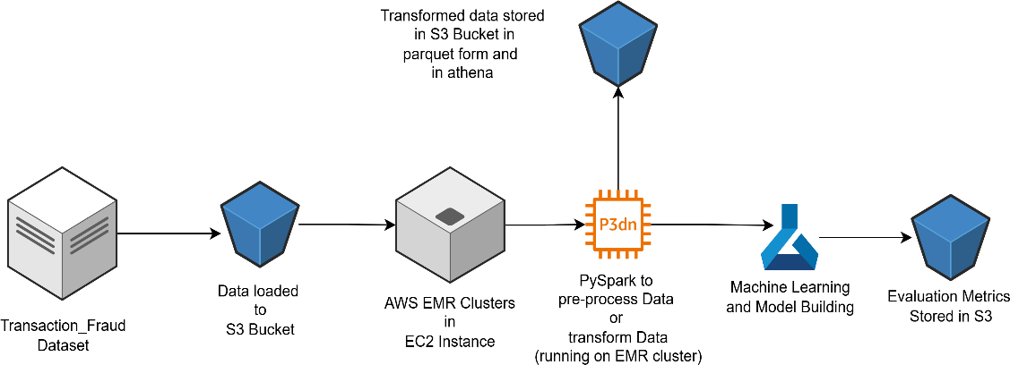
Architecture Diagram:
Poker_hand dataset

Full Architecture Diagram:
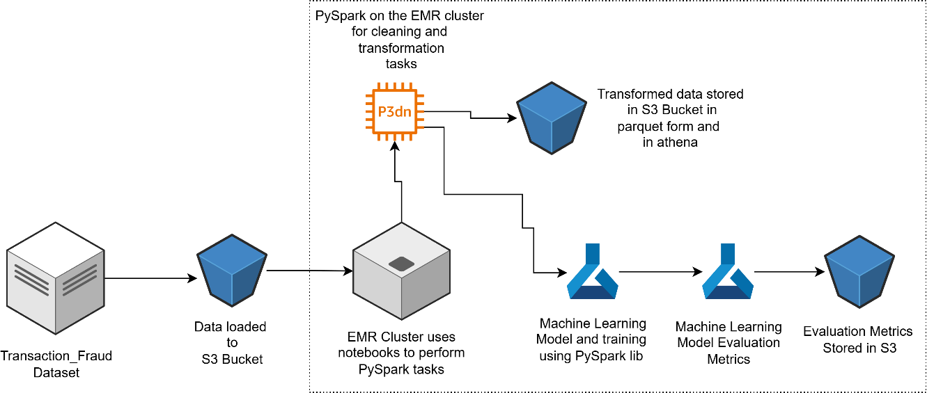
Poker_hand dataset

Challenges Faced:
- Handling large datasets efficiently in a distributed environment.
- Ensuring models were optimized for multi-class classification.
- Reducing computation time while maintaining high accuracy.
Benefits of Distributed Computing:
- Scalability: Efficiently handles large datasets without performance degradation.
- Speed: Parallel processing improves training and inference times.
- Fault Tolerance: Ensures reliable execution even in distributed environments.
Conclusion and Future Work:
- Gradient Boosting performed the best but had high computation time.
- Random Forest provided a good trade-off between accuracy and speed.
- Further feature selection techniques can be applied to improve model efficiency.
- Exploring deep learning techniques could further improve classification performance.
This project successfully implemented machine learning models for Poker Hand Classification, demonstrating how PySpark can be used for large-scale classification tasks.

